Quarterly Report – Public Page

Date of Report: 8th Quarterly Report- September 27, 2024
Contract Number: 693JK32210002POTA
Prepared for: Government Agency: DOT and Co-funders
Project Title: Monitoring the Long-Term Compatibility of Vapor Corrosion Inhibitor and Cathodic Protection Associated Components
Prepared by: Pipeline Research Council International, Inc.
Contact Information: Janie Norton, email: jnorton@prci.org
For quarterly period ending: September 30, 2024

1: Items Completed During this Quarterly Period:

Item # | Task # | Activity/Deliverable | Title | Federal Cost | Cost Share
20 | 4 | Inject VCIs in the laboratory and large-scale experiments | Summary to be included in quarterly report | $3,258 | $3,258
28 | 2 | Monitor progress of various field testing | Summary of the progress to be included in quarterly report | $1,303 | $1,303
29 | 5 | Quarterly status report & project management | Submit 8th quarterly report | $4,249 | $4,249

2: Items Not Completed During this Quarterly Period:

Item # | Task # | Activity/Deliverable | Title | Federal Cost | Cost Share
27 | 3 | Finish VCI compatibility with non-sand pad materials laboratory test, analyze data and draw conclusions | Summary of the data to be included in the quarterly report | $9,773 | $9,773

3: Project Financial Tracking During this Quarterly Period:

Note that this chart reflects Federal share only.

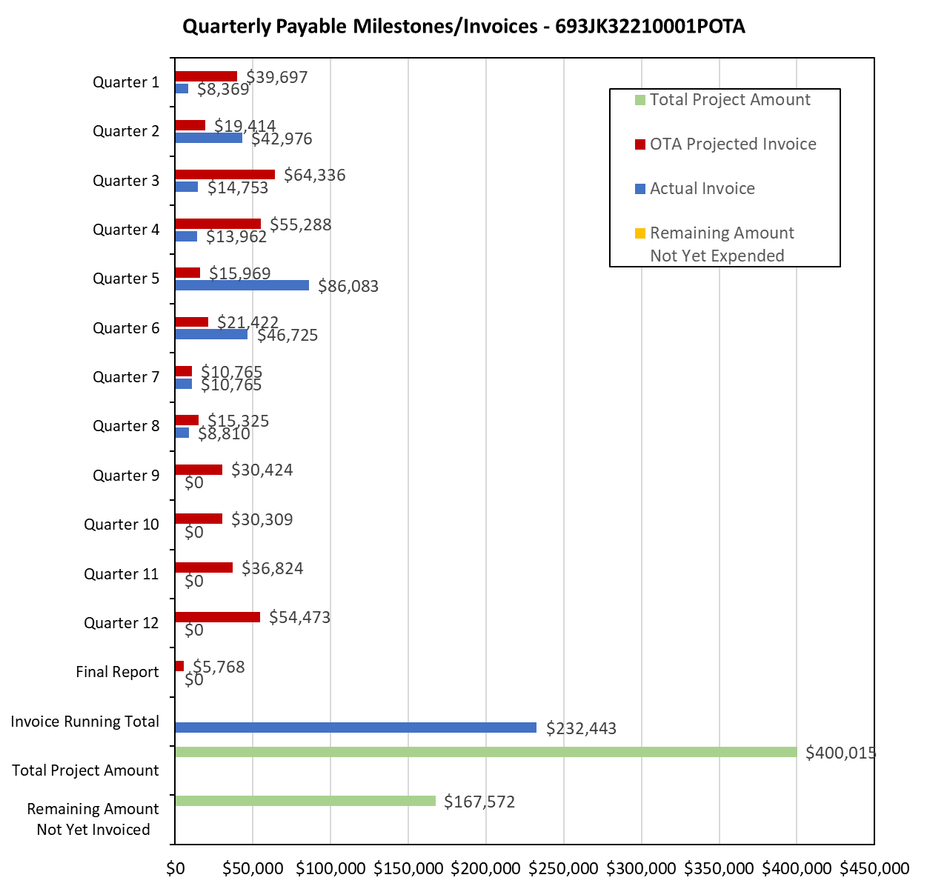

4: Project Technical Status:

Item 20, Task 4 ⎯ Inject VCIs in the laboratory and large-scale experiments. Summary to be included in quarterly report: The revised design of the laboratory experiments over VCI migration in the clay-like pads include VCI delivery at the start of the experiments. The VCI injections in the laboratory experiments have been completed. Regarding the two large-scale experiments, VCI injection schedule was determined based on ER probe data. One of the VCIs was injected in the first large-scale experiment during the early part of the seventh quarter. Similarly, another VCI chemistry was injected in the second large-scale experiment in the wight quarter. This activity links to item 9 as listed in Attachment 1 Team Project Activities. This activity also satisfies item 14 in Attachment 2 Project Deliverables.

Item 28, Task 2 ⎯ Monitor progress of the various field testing. Summary of the progress to be included in quarterly report: The field testing for the VCI-treated tanks and recently-VCI-treated tanks was started in the 5th quarter. The monitoring data for two quarters have been collected for those tanks. The field sand samples from the previously treated VCI tanks have been received and analyzed. The field sand samples from the recently-treated-with-VCI tanks have also been received and have been analyzed. The mass-loss coupons that were placed under some of the VCI treated tanks were removed and received. The mass-loss coupons will be analyzed in the next quarter. In addition, the monitoring data for electrical resistance (ER) and UT probes were collected during the seventh quarter; the eight quarter readings will be collected in October 2024, and the ninth quarter reading will be collected December 2024. The eight-quarter field data collection was delayed due to scheduling and maintenance issues at the field-testing terminals. This activity links to items 6 and 7 as listed in Attachment 1 Team Project Activities. This activity also satisfies item 18 in Attachment 2 Project Deliverables.

Item 29, Task 5 ⎯ Quarterly status report & project management. Submit 8th quarterly report: The 8th quarter project meeting was held; the meeting minutes are provided in the Appendix. This item has been completed, and it partly satisfies item 25 in Attachment 2 Project Deliverables. It also links to item 13 as listed in Attachment 1 Team Project Activities. The meeting minutes in the appendix link to item 11 as listed in Attachment 1 Team Project Activities.

5: Project Schedule:

Item 27, Task 5 ⎯ Finish VCI compatibility with non-sand pad materials laboratory test, analyze data and draw conclusions. Summary of the data to be included in the quarterly report: the various experiments were started toward the end of 6th quarter. The coupons in the various experiments have just finished 6-month exposure. The experiments will be taken down in the next couple of weeks and the associated data and conclusions will be submitted for review to the project team. This task will be completed by the next quarter.

Overall, the project is a bit behind schedule, but activities will catch up in the next quarter.

